 | The marine expedition TRANSARCTIC

The expedition "TRANSARCTICA – 2019, the first stage" precedes the work of the international floating Observatory, planned to be deployed in the framework of the MOSAiC project (The Multi-Disciplinary drifting Observatory for the study of Arctic Climate programme). Taking into account, the scientific and practical results obtained in the expedition will contribute to the successful implementation of the MOSAiC project.

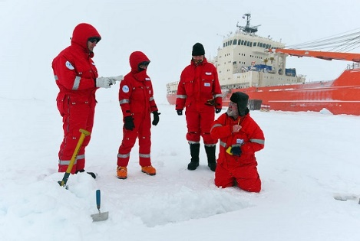

The members of the expedition are taking snow samples for isotope analysis

On March 20, 2019, the marine expedition TRANSARCTIC began with the release of the scientific expedition vessel "Academic Tryoshnikov" from the Murmansk port.
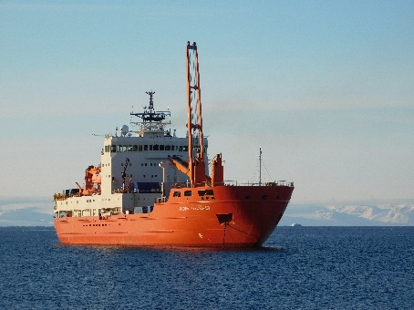
The research vessel "Academic Tryoshnikov". Photo by Vasili Povazhny, AARI (Arctic and Antarctic Research Institute)
The Transarctic is a large-scale project of Roshydromet, continuing the research traditions of the sea, air expeditions and drifting stations "North pole" in the high-latitude Arctic.

News of the expedition

http://www.aari.ru/transarctika2019/ta_news.php

To monitor drift

http://www.aari.ru/transarctika2019/dreif.html

Scientific program

http://www.aari.ru/transarctika2019/ta_prog.html

The ongoing changes in ice conditions in the high-latitude Arctic made the work of scientists on drifting ice very difficult. Therefore, in 2013 the work of the last full-scale drifting research station "North pole-40" was stopped.
The project is intended to resume comprehensive research in the Arctic basin and to test new technologies for the operation of the ice-resistant platform "North pole", the construction of which is being commissioned by Roshydromet.

The Scientific Program of the maritime expedition TRANSARCTICA 2019

The main purpose of the work is to provide comprehensive studies of hydrometeorological processes in high latitudes in the conditions necessary to improve weather and climate forecasting models and increase their accuracy. Understanding the peculiarities of the Arctic natural environment development and its probable changes in the scale of the foreseeable time is of fundamental scientific and practical importance.
The scientific program of work of the drifting station is aimed at the study of the ocean-ice-atmosphere system and near space with the use of modern technical means, buoy systems, large-scale oceanographic surveys from helicopters, observations from the ice and ships, satellite monitoring. According to preliminary calculations, the drift of the vessel will last until mid-late may, after which the research vessel "Academic Tryoshnikov" will come out of the ice and head to the port of Murmansk.
The expedition "TRANSARCTICA – 2019, the first stage" precedes the work of the international floating Observatory, planned to be deployed in the framework of the MOSAiC project (The Multi-Disciplinary drifting Observatory for the study of Arctic Climate programme). Taking into account, the scientific and practical results obtained in the expedition will contribute to the successful implementation of the MOSAiC project.
The expedition consists of four stages, which will work under a joint program. At each stage, full-scale interdisciplinary studies of changes in the natural environment of the Arctic Ocean will be carried out. Unique data will allow scientists to assess the patterns of formation of the state of the Arctic environment and its likely changes in the conditions of modern global warming. These studies will contribute to the improvement of weather and climate forecasting models necessary to ensure safe navigation in the waters of the Northern sea route.

The first stage of the expedition
Start: March 20, 2019
Duration: 70-100 days
The research vessel: "Academic Tryoshnikov»
Scientific program: the study of the ocean-ice-atmosphere and near space using modern technology, buoy systems, large-scale Oceanographic surveys from helicopters, observations from ice and ship, satellite monitoring.
The seasonal drifting research station "North pole–2019" will be organized on the basis of the RV "Academic Tryoshnikov". The ship will be put into the ice in the North of the Franz Josef Land archipelago, where it will begin its drift.
According to preliminary calculations, the drift of the vessel will last until mid-late may, after which the "Academic Tryoshnikov" will come out of the ice and head to the port of Murmansk.
During the first stage, the technologies of operation and staffing of the ice-resistant self-moving platform "North pole" will be tested, the design and construction of which since 2018 is carried out by JSC "Admiralty shipyards" on the order of Roshydromet. The data obtained will become the fundamental basis for the Russian national Arctic spatially distributed scientific Observatory.

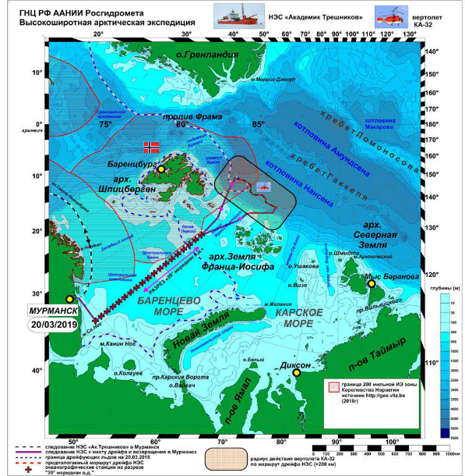
The route of the first stage of the expedition (http://www.aari.ru/transarctika2019/transarctika2019.html)

The second stage of the expedition
Beginning: 15 May 2019
Duration: 26 days
The Research vessel "Mikhail Somov»
Scientific program: state monitoring of the natural environment in the Barents Sea.
Hydrometeorological observations, monitoring of ice conditions and wildlife will be carried out along the route of the vessel. The main purpose of the work is to assess the state of the waters, marine and coastal ecosystems of the Arctic seas in connection with global climate change and obtain operational information on the state of marine ecosystems.
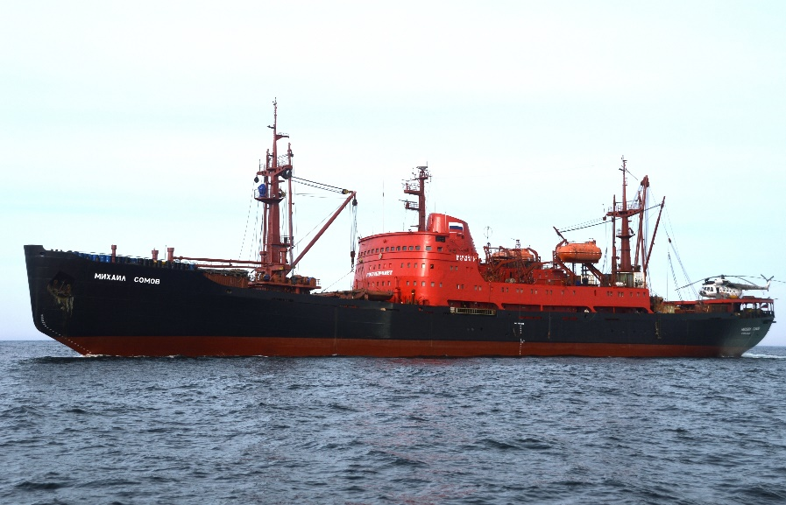
The Research vessel "Mikhail Somov"

The third stage of the expedition
Start: July 16, 2019
Duration: 18 days
The Research vessel "Professor Molchanov»
Scientific program: carrying out complex research works in the White and Barents seas as part of an educational project for students of Russian universities.

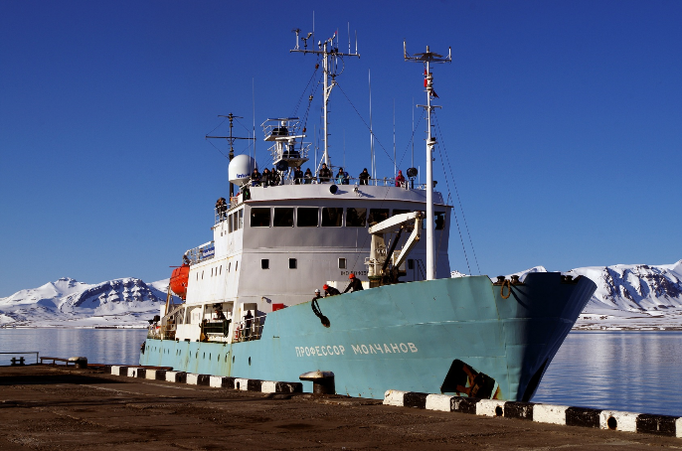
The research vessel "Professor Molchanov". Photo AARI

The main purpose of the work is to promote polar research among young people. During the implementation of complex expedition studies of ecosystems of the Arctic seas and coasts, students of Russian universities will receive practical skills in the high-latitude Arctic.
This stage is organized, among other things, for the purpose of training researchers to work on the ice-resistant platform "North pole" and in the institutions of Roshydromet.

The fourth stage of the expedition
Beginning: July 2019
Duration: 90 days
The research vessel "Professor Multanovsky»
Scientific program: state monitoring of the natural environment in the waters from the Chukchi to the Barents seas.
Scientists will work to restore the regular system of state comprehensive monitoring of the state and pollution of the environment of the marginal Arctic seas of Russia

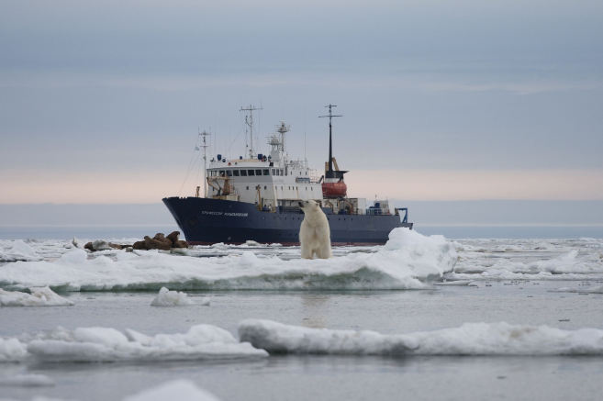
The research vessel "Professor Multanovsky". Photo FERHRI (Far Eastern Regional Hydrometeorological Research Institute)

All flights of the project will be provided with the necessary operational hydrometeorological prognostic information provided by the scientific organizations of Roshydromet.

News of the expedition

http://www.aari.ru/transarctika2019/ta_news.php

To monitor drift

http://www.aari.ru/transarctika2019/dreif.html

Scientific program

http://www.aari.ru/transarctika2019/ta_prog.html

